**WEB DEVELOPMENT FILE**

**Bachelor of Technology**

*in*

**Information Technology**





**By: Tarun Daderwal**

**Enrollment Number: 10813203121**

**Class: IT-2(FSD)**

**To: Mrs. Kritika Balihar**

**Subject: Web Development using Mern Stack**

**Index**

| Sr. No. | Practical | Given | Submitted | Signature |
| --- | --- | --- | --- | --- |
|  |  |  |  |  |
|  |  |  |  |  |
|  |  |  |  |  |
|  |  |  |  |  |
|  |  |  |  |  |
|  |  |  |  |  |
|  |  |  |  |  |
|  |  |  |  |  |

**Practical – 3(a)**

**Aim:** Write a programto Create Time Table using HTML.

**Code:**

<!doctype html>

<html lang="en">

<head>

<title> Time-Table </title>

<meta charset="utf-8">

<meta name="viewport" content="width=device-width, initial-scale=1.0">

<style>

h2{

text-align: center;

}

</style>

</head>

<body>

<h2>Time Table</h2>

<table border="1" style="border-collapse: collapse;" cellspacing="10px" cellpadding="6px" align="center">

<tr>

<td colspan="9" align="center">3rd Year, IT(FSD)</td>

</tr>

<tr width="100%" height="30px" align="center">

<td></td>

<td>08:00-09:00</td>

<td>09:00-10:00</td>

<td>10:00-11:00</td>

<td>11:00-12:00</td>

<td>BREAK</td>

<td>12:30-01:30</td>

<td>01:30-02:30</td>

<td>02:30-03:30</td>

</tr>

<tr align="center">

<td>&nbsp Monday &nbsp </td>

<td colspan="2">Advanced Java Lab_B <hr>Ms. Gurjapna Kaur</br><br>Lab 12</td>

<td colspan="2">Web Development Lab_B <hr> Ms. Kritika <br><br> Lab 12</td>

<td>--X--</td>

<td>E-Commerce_Th <hr> Mr. Kalyan Singh <br><br> Lect 32</td>

<td>PME_Th <hr> Mr. Sachin<br><br> Lect 34</td>

<td>Web Development_Th <hr> Ms. Kritika <br><br> Lect 34</td>

</tr>

<tr align="center">

<td>&nbsp Tuesday &nbsp </td>

<td colspan="2">Advanced Java_Th <hr>Ms. Gurjapna Kaur</br><br>Lect 32</td>

<td>DBM_Th<hr> Ms. Upasana <br><br> Lect 32</td>

<td>PME_Th <hr> Mr. Sachin <br><br> Lect 32</td>

<td>--X--</td>

<td>E-Commerce_Th <hr> Mr. Kalyan Singh <br><br> Lect 34</td>

<td>Web Development_Th <hr> Ms. Kritika <br><br> Lect 34</td>

<td>Web Technology_Th <hr> Ms. Gurpreet Kaur<br><br> Lect 33</td>

</tr>

<tr align="center">

<td>&nbsp Wednesday &nbsp </td>

<td colspan="2">Web Development Lab_B <hr> Ms. Kritika <br><br> Lab 12</td>

<td colspan="2">Web Technology Lab_B <hr>Ms. Gurpreet Kaur</br><br>Lab 12</td>

<td>--X--</td>

<td>Web Technology_Th <hr> Ms. Gurpreet Kaur<br><br> Lect 33</td>

<td>E-Commerce_Th <hr> Mr. Kalyan Singh <br><br> Lect 33</td>

<td>DBM_Th<hr> Ms. Upasana <br><br> Lect 34</td>

</tr>

<tr align="center">

<td>&nbsp Thursday &nbsp </td>

<td>Web Development_Th <hr> Ms. Kritika <br><br> Lect 33</td>

<td>DBM_Th<hr> Ms. Upasana <br><br> Lect 33</td>

<td>Web Technology_Th <hr> Ms. Gurpreet Kaur<br><br> Lect 32</td>

<td>UHV-1_Th<hr> Ms. Chetna Nassa <br><br> Lect 32</td>

<td>--X--</td>

<td>PME_Th <hr> Mr. Sachin<br><br> Lect 32</td>

<td>E-Commerce_Th <hr> Mr. Kalyan Singh <br><br> Lect 32</td>

<td>-----</td>

</tr>

<tr align="center">

<td>&nbsp Friday &nbsp </td>

<td colspan="2">Advanced Java Lab_A <hr>Ms. Gurjapna Kaur</br><br>Lab 12</td>

<td>DBM_Th<hr> Ms. Upasana <br><br> Lect 32</td>

<td>Advanced Java_Th <hr>Ms. Gurjapna Kaur</br><br>Lect 32</td>

<td>--X--</td>

<td colspan="2">Web Technology Lab_B <hr> Ms. Gurpreet Kaur <br><br> Lab 12</td>

<td>-----</td>

</tr>

<tr align="center">

<td>&nbsp Saturday &nbsp </td>

<td>-----</td>

<td>-----</td>

<td>-----</td>

<td>-----</td>

<td>--X--</td>

<td>-----</td>

<td>-----</td>

<td>-----</td>

</tr>

</table>

</body>

</html>

**Output:**

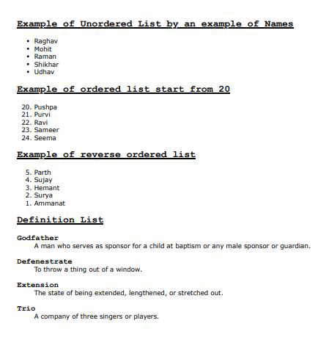

**Practical – 3(b)**

**Aim:** Write a program to create Nested List (Ordered, Unordered & Definition List) using HTML.

**Code:**

<!doctype html>

<html lang="en">

<head>

<title>Ordered-Unordered List</title>

<meta charset="utf-8">

<meta name="viewport" content="width=device-width, initial-scale=1.0">

</head>

<style>

h2, dt{

font-family: courier;

}

li, dd{

font-family: verdana;

}

dt{

font-size: 120%;

font-weight: bold;

}

</style>

<body>

<h2><u>Example of Unordered List by an example of Names</u></h2>

<ul>

<li>Raghav</li>

<li>Mohit</li>

<li>Raman</li>

<li>Shikhar</li>

<li>Udhav</li>

</ul>

<h2><u>Example of ordered list start from 20</u></h2>

<ol start = "20">

<li>Pushpa</li>

<li>Purvi</li>

<li>Ravi</li>

<li>Sameer</li>

<li>Seema</li>

</ol>

<h2><u>Example of reverse ordered list</u></h2>

<ol reversed>

<li>Parth</li>

<li>Sujay</li>

<li>Hemant</li>

<li>Surya</li>

<li>Ammanat</li>

</ol>

<div>

<h2><u>Definition List</u></h2>

<dl>

<dt>Godfather</dt>

<dd>A man who serves as sponsor for a child at baptism or any male sponsor or guardian.</dd></br>

<dt>Defenestrate</dt>

<dd>To throw a thing out of a window.</dd></br>

<dt>Extension</dt>

<dd>The state of being extended, lengthened, or stretched out.</dd></br>

<dt>Trio</dt>

<dd>A company of three singers or players.</dd></br>

</dl>

</div>

</body>

</html>

**Output:**

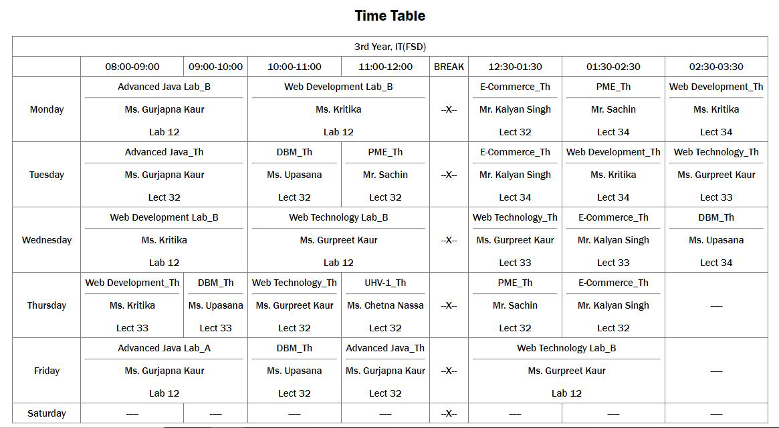

**Practical – 4(a)**

**Aim:** Write a Program to Create Registration Form Using HTML.

**Code:**

<!doctype html>

<html>

<head>

<title> Registration form </title>

<meta charset="utf-8">

</head>

<body>

<style>

body {

font-family: verdana;

margin: 0;

padding: 0;

background-color: #f4f4f4;

}

#container {

width: 40%;

margin: 10vh auto;

padding: 20px;

background-color: #fff;

border-radius: 10px;

box-shadow: 0 0 10px rgba(0, 0, 0, 0.1);

}

form {

padding: 15px;

}

label {

display: block;

margin-bottom: 10px;

font-weight: bold;

}

input[type="text"], input[type="email"], input[type="password"] {

width: 100%;

padding: 10px;

border: 1px solid #ccc;

border-radius: 5px;

box-sizing: border-box;

}

input[type="submit"] {

background-color: #333;

color: #fff;

padding: 10px 20px;

border: none;

border-radius: 5px;

cursor: pointer;

}

input[type="submit"]:hover {

background-color: #555;

}

</style>

<div id="container">

<form>

<label for="username">Username:</label><br>

<input type="text" id="username" name="username" placeholder="Username" required><br><br>

<label for="email">Email:</label><br>

<input type="email" id="email" name="email" placeholder="Email" required><br><br>

<label for="password">Password:</label><br>

<input type="password" id="password" name="password" placeholder="Password" required><br><br>

<label for="confirm_password">Confirm Password:</label><br>

<input type="password" id="confirm_password" name="confirm_password" placeholder="Confirm Password" required><br><br>

<input type="submit" value="Register">

</form>

</div>

</body>

</html>

**Output:**

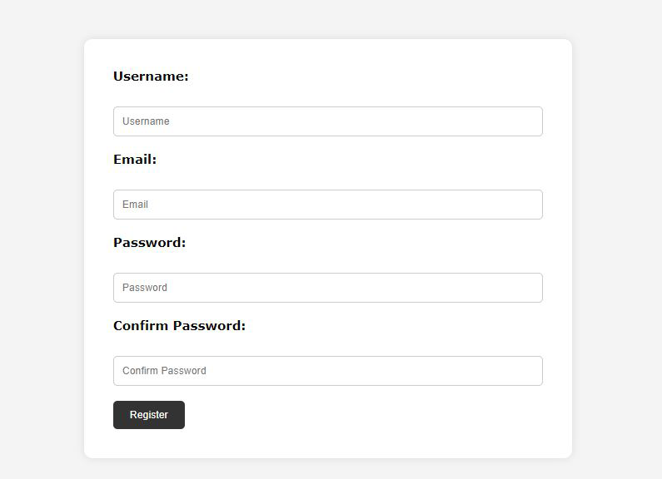

**Practical – 4(b)**

**Aim:**

**Code:**

<!doctype html>

<html>

<head>

<title> Frame and Hyperlinks </title>

<meta charset="utf-8">

<meta name="viewport" content="width=device-width, initial-scale=1.0">

</head>

<body>

<style>

body {

font-family: Arial, sans-serif;

padding: 0;

background-color: #f4f4f4;

}

p {

display: flex;

justify-content: space-between;

align-items: center ;

font-size: 20px;

padding: 10px;

margin-top: 20px;

text-align: center;

background-color: black;

}

a {

text-decoration: none;

color: white;

}

</style>

<iframe src="https://webflow.com/made-in-webflow/iframe" width="49%" height="570px"></iframe>

<iframe src="https://www.pexels.com/" width="50%" height="570px"></iframe>

<p>

<u>Some more links - ></u>

<i><a href="https://www.accuweather.com/en/in/delhi/202396/weather-forecast/202396">Accu Weather</a></i><br>

<i><a href="https://www.google.com">Google</a></i><br>

<i><a href="https://www.youtube.com">Youtube</a></i><br>

</p>

</body>

</html>

**Output:**

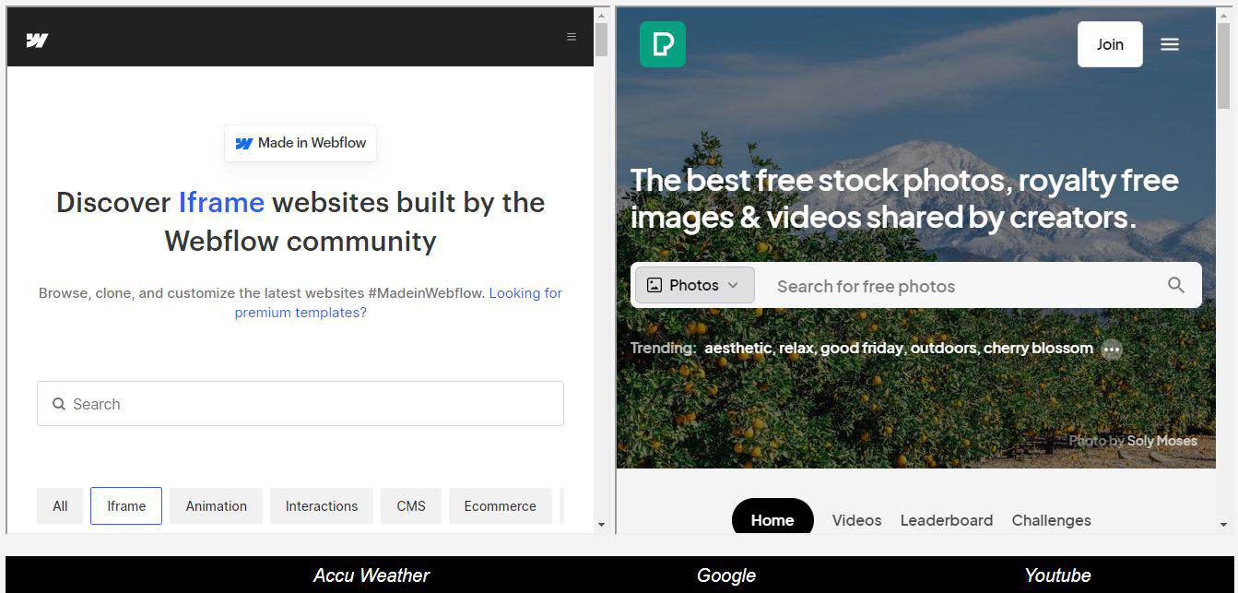

**Practical – 5(a)**

**Aim:**

**Code:**

<!DOCTYPE html>

<html lang="en">

<head>

<meta charset="UTF-8">

<meta name="viewport" content="width=device-width, initial-scale=1.0">

<title>Static Webpage</title>

</head>

<body>

<style>

body {

font-family: Arial, sans-serif;

margin: 0;

padding: 0;

}

header {

background-color: #333;

color: #fff;

padding: 10px 0;

text-align: center;

}

nav {

background-color: black;

padding: 10px;

}

nav a {

text-decoration: none;

color: white;

padding: 5px 10px;

margin: 0 5px;

}

nav a:hover{

background-color: #323333;

}

img{

display: block;

margin-left: auto;

margin-right: auto;

width: 900px;

height: 190px;

}

#query{

text-align: center;

}

#query p{

font-family: verdana;

margin-left: auto;

margin-right: auto;

border-radius: 20px;

border: 1px solid #303333;

padding: 10px;

width: 300px;

height: 20px;

background-color: #b0b2b5;

}

#input1{

border-radius: 12px;

border: 1px solid black;

padding: 10px;

width: 200px;

height: 15px;

}

#button{

border-radius: 12px;

padding: 10px;

font-weight: bold;

}

#button:hover{

background-color: #b5b8b4;

cursor: pointer;

}

section {

padding: 20px;

}

footer {

background-color: #333;

color: #fff;

text-align: center;

padding: 19px 0;

position: flexible;

bottom: 0;

width: 100%;

}

</style>

<header>

<h1>Static Webpage</h1>

</header>

<div id="navigation">

<nav>

<a href="#">Home</a>

<a href="#">About</a>

<a href="#">Services</a>

<a href="#">Contact</a>

</nav>

</div>

<section>

<div>

<h2>Welcome to my Static Webpage</h2>

<p>Lorem ipsum dolor sit amet, consectetur adipiscing elit. Sed ullamcorper urna eget tortor accumsan, vel vulputate mauris placerat. Nam in ex id ipsum interdum aliquam in vel nulla. Suspendisse sit amet turpis vestibulum, sagittis purus sit amet, efficitur sem. Cras id dolor at nibh pellentesque volutpat non id ipsum. Fusce dui libero, tristique nec eleifend id, egestas non lacus. Suspendisse in sem sit amet velit bibendum venenatis. Donec dolor nulla, fermentum nec laoreet ac, pulvinar vitae odio. Sed sed neque at est suscipit posuere bibendum a tortor. Mauris faucibus purus molestie ligula consectetur faucibus. Sed dapibus viverra tortor a vestibulum. Ut eu ex a purus malesuada fringilla eget sed dolor. Pellentesque habitant morbi tristique senectus et netus et malesuada. </p>

</div>

<div id="image">

<img src="https://images.pexels.com/photos/51387/mount-everest-himalayas-nuptse-lhotse-51387.jpeg?auto=compress&cs=tinysrgb&w=1260&h=750&dpr=1">

</div>

<div id="query">

<p><u><strong>Have queries!! Send us...</strong></u></p>

<form name="contact" method="post">

<input type="text" id="input1" name="query" />

<input type="submit" name="button" id="button" value="Submit" />

</form>

</div>

</section>

<footer>

<div id="currentTime"></div>

</footer>

<script>

function updateTime() {

var now = new Date();

var hours = now.getHours();

var minutes = now.getMinutes();

var seconds = now.getSeconds();

minutes = (minutes < 10 ? '0' : '') + minutes;

seconds = (seconds < 10 ? '0' : '') + seconds;

var timeString = hours + ':' + minutes + ':' + seconds;

document.getElementById('currentTime').textContent = '© 2024 My Static Website | Time: '+timeString;

}

setInterval(updateTime, 1000);

updateTime();

</script>

</body>

</html>

**Website Deployment:** I have deployed my website on Netlify because Netlify is fast, secure, cost-effective, and easily integrates with many tools. It is a great platform for hosting static websites. I have deployed my website on link <https://staticw.netlify.app/> .

**Output:**

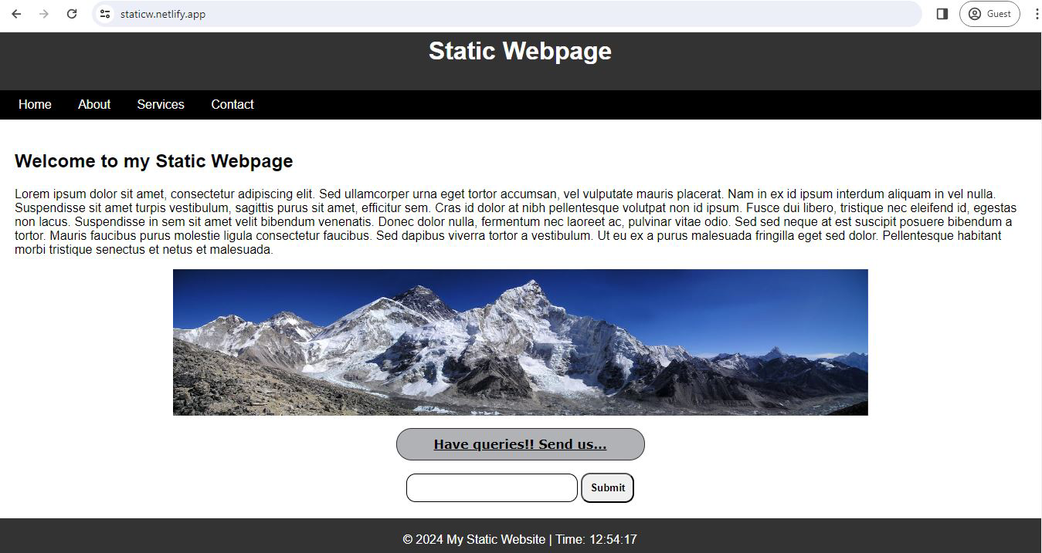

**Practical – 5(b)**

**Aim:**

**Theory:**

Steps for installation:

1. **Download and Install Node.js:**

* Visit the official Node.js website at <https://nodejs.org/>.
* Download the appropriate installer for your operating system (Windows, macOS, or Linux).
* Run the installer and follow the on-screen instructions to complete the installation process.

1. **Verify Node.js Installation:**

* Open a command prompt or terminal window.
* Type the following command and press Enter:

node -v

* If Node.js is installed successfully, you should see the version number displayed in the terminal.



1. **Create a New Node.js Project:**

* Choose or create a directory where you want to set up your Node.js project.
* Open a command prompt or terminal window and navigate to the chosen directory.
* Run the following command to initialize a new Node.js project:

npm init -y

* This command creates a new **package.json** file in your project directory with default values.

1. **Install Express.js:**

* With Node.js initialized, you can now install Express.js as a dependency for your project.
* Run the following command in the terminal to install Express.js:

npm install express

* This command installs Express.js and adds it as a dependency in your **package.json** file.

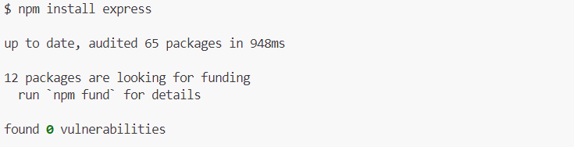

1. **Create a Basic Express.js Application:**

* Create a new JavaScript file (e.g., **app.js**) in your project directory.
* Open **app.js** in a text editor and import Express.js:

const express = require('express'); const app = express();

* Define a route that responds with "Hello, World!" when accessed:

app.get('/', (req, res) => { res.send('Hello, World!'); });

* Start the Express.js server and listen for incoming requests on a specified port:

const port = 3000; app.listen(port, () => { console.log(`Server is running on http://localhost:${port}`); });

1. **Run the Express.js Application:**

* Save the changes to **app.js**.
* In the terminal, navigate to your project directory.
* Run the following command to start the Express.js server:

node app.js

* If everything is set up correctly, you should see the message "Server is running on http://localhost:3000" logged to the terminal.
* Open a web browser and navigate to **http://localhost:3000** to see the "Hello, World!" message displayed.



